Table of Contents

1. Version History 3

2. Introduction 3

3. Targeted Audience 4

4. Scope 4

5. Application Architecture 5

Presentation Tier 5

Application Tier 6

Data Tier 7

6. Business Architecture 8

7. Detailed Design 14

8. Data Architecture 16

Table Structure and Relationships 16

9. Testing Model 18

Testing Model for Food Waste Reduction Platform (FWRP) 18

10. References 20

11. Acronyms/Abbreviations 20

12. List of Figures 21

**Food Waste Reduction Platform Design Document**

# 1. Version History

* Version 2.0
* Authors: Pawinee Mahantamak (Team Leader), Beulah Nwokotubo, Sreelakshmi Odatt Venu, Jessica Gunawan
* Date Last Modified: 20th March 2024

# 2. Introduction

The global issue of food waste poses significant challenges to sustainability and food security. Addressing this problem requires solutions that use technology to facilitate collaboration among stakeholders across the food supply chain. The Food Waste Reduction Platform (FWRP) is a comprehensive solution designed to tackle this issue by connecting food retailers, consumers, and charitable organizations.

The aim of the FWRP is to promote sustainability and reduce hunger by facilitating the **efficient** redistribution of surplus food. This platform provides a user-friendly interface that allows food retailers to manage their inventory, identify surplus food items, and list them for donation or sale at discounted rates. Charitable organizations such as food banks can easily claim surplus food items listed by retailers, ensuring that excess food is redirected to those in need. Additionally, consumers can purchase surplus food items at reduced prices, further reducing food waste while providing affordable options for individuals and families.

This document serves as a guide to the design and architecture of the FWRP, outlining its functional requirements, architectural components, and design considerations involved in its development.

Through the collaborative efforts of stakeholders (retailers, consumers, and charitable organizations), technological innovation, and a commitment to sustainability, the FWRP aims to make a meaningful impact in the fight against food waste, to create a more equitable and sustainable future for us all.

# 3. Targeted Audience

* **Software Architects:** responsible for designing the overall structure of software systems, including the FWRP. They define the architecture, components, and interactions to ensure scalability, reliability, and maintainability of the system.
* **Software Developers:** responsible for implementing the design and functionality of the FWRP. They write code, develop features, and integrate various components to create a working software application.
* **Project Managers:** Project managers oversee the planning, execution, and monitoring of the FWRP development project. They coordinate resources, manage timelines, and ensure that the project is delivered on time and within budget.
* **Charitable Organizations:** may participate in the FWRP by claiming surplus food items from retailers and distributing them to communities in need.
* **Retailers:** retailers can list surplus food items nearing expiration or in excess of demand for donation or sale at discounted prices.
* **Consumer:** consumers may benefit from purchasing surplus food items listed by retailers at reduced prices, thereby reducing food waste and accessing affordable food options.

# 4. Scope

* **In Scope:**
* Design and architecture details of the Food Waste Reduction Platform.
* Use case diagrams and descriptions.
* Class diagrams and component diagrams.
* Database structures and entity-relationship diagrams.
* Testing strategies and approaches.
* **Out of Scope:** Implementation specifics, detailed coding guidelines.
* Detailed implementation of the code.
* Non-technical aspects such as marketing strategies or business plans.
* Detailed explanations or implementations of individual design patterns.
* In-depth discussions of design pattern principles or theory.

Figure 1: Application Architecture

### Presentation Tier

* Users interact with the platform through various client devices, including web browsers on PCs, email clients, and phones.
* The web application server, using Apache Tomcat, serves as the bridge between the client PCs with web browsers and the application tier.
* Users access the platform's functionalities through the web application server.

**How it works**

When you log in to our platform from your computer, you will see options to browse surplus food items, claim items from retailers, or purchase items at discounted rates based on their role. Similarly, if you receive a notification on your phone about surplus food availability, you can click the link to view details directly from your device.

# Application Tier

The application tier consists of several components:

**Web Application Server (Apache Tomcat)** Handles HTTP requests from client web browsers and sends responses back.

**Servlet Container:** Manages and executes Java Servlets.

**Web Components, JavaBeans Component, and JDBC**: Responsible for implementing business logic, processing requests, and interacting with the database.

**Integration with Client Mail and Client Phone**: The application tier communicates with external mail and SMS servers (SMTP and SMPP) using JavaBeans components. SMTP (Simple Mail Transfer Protocol) is used for email communication, while SMPP (Short Message Peer-to-Peer) is used for SMS communication. JavaBeans components interface with these protocols to send notifications and alerts to users. For the libraries or APIs, we used JavaMail for SMTP and SMPP libraries for SMPP.

This integration allows the platform to send notifications and alerts to users via email and SMS, enhancing user engagement and communication.

**How it works**

* When a retailer lists surplus food items, the application tier ensures that the items are properly categorized, listed, and made available for claiming or purchasing. It also manages user authentication, ensuring that only authorized users can access specific functionalities such as listing items or claiming them.
* Web components handle the user interface elements, ensuring that the platform's design remains consistent and user-friendly. JavaBeans manages business logic, such as determining eligibility for claiming surplus food items based on user preferences. JDBC facilitates communication with the database, allowing the platform to retrieve or update information as needed.
* When a retailer lists surplus food items, the application tier triggers notifications. For instance, it sends email alerts to subscribed users and SMS notifications to those who prefer texts. Components like JavaBeans handle the notification process, coordinating with external servers for delivery.

# Data Tier

* The data tier comprises the database server, MySQL, which stores and manages the platform's persistent data.
* JDBC is used to establish connections between the application tier and the database server, enabling the platform to perform database operations such as CRUD (Create, Read, Update, Delete).

**How it works**

* MySQL ensures that data is stored efficiently and can be retrieved quickly when needed. It maintains relationships between different types of data, such as linking surplus food items to the retailers who listed them and the users who claimed them. This ensures data integrity and consistency across the platform.
* When a user lists a surplus food item for donation, the platform stores the item details, including its name, quantity, expiration date, and location. This information is stored securely in the database, ensuring that it remains accessible and accurate.

# 6. Business Architecture

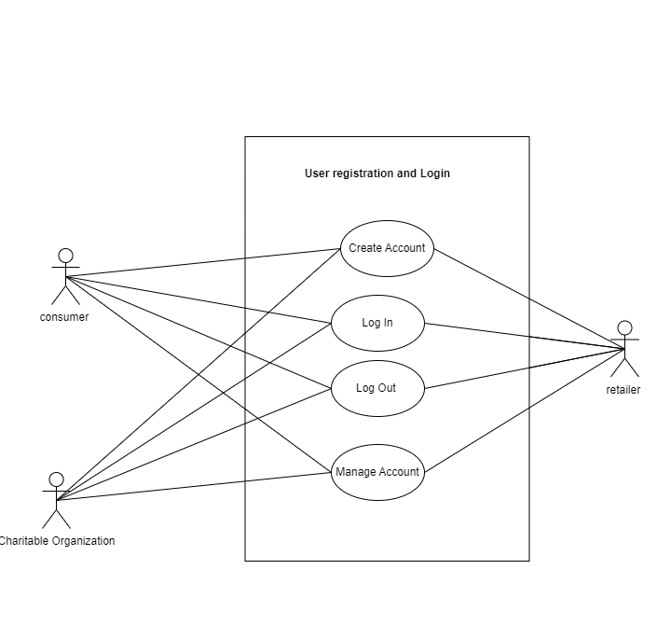

Figure 2: User Registration and Login Use Case

**Use Case Title:** User Registration and Login

**Use Case ID:** 01

**Actors:** Users (Retailers, Costumers, Charitable Organization)

**Description:** Registration involves the actors (consumers, charitable organizations, and retailers) creating an account in the system. This normally entails several use cases, such as entering some personal information, such as name, address line, city, province, and postal code, and selecting a username and password, entering their login and password to gain access to the system, signing out of their account to end their session in the system ends, as well as managing accounts involves adding or updating their account information. This may include changing their password, updating personal information, or customizing settings.

**Preconditions:**

* Users have not registered.
* Users have access to the application.

**Main Success Scenario:**

1. User (consumer, charitable organization, retailer) creates an account.
2. User inputs personal information such as name, address, and their roles to choose from consumer, charitable organization, retailer.
3. User picks a username and password.
4. User inputs username and password that match.
5. User accesses their account upon successful login.
6. User logs out to end session.
7. Users can add/update their personal information.
8. User privacy and support is provided.

**Alternative Scenario:**

1. User inputs username and password that does not match.
2. System shows invalid password message and login fails.

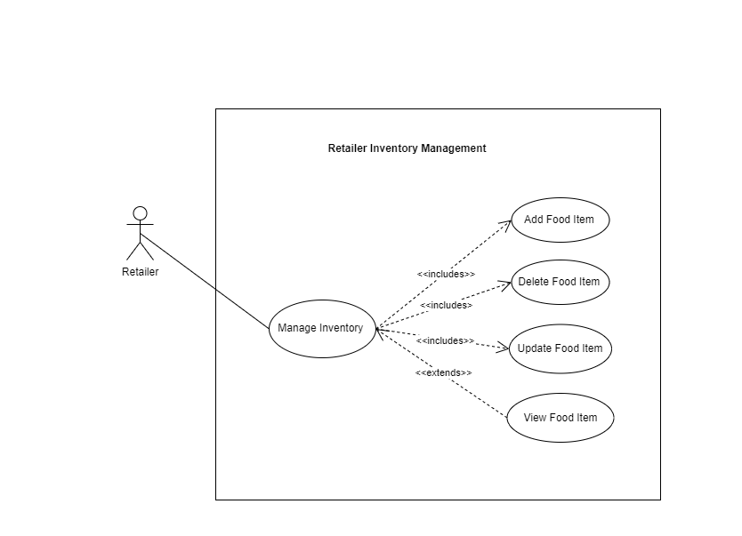

Figure 3: Retailer Inventory Management Use Case

**Use Case Title:** Retailer Inventory Management

**Use Case ID:** 02

**Actors:** Retailer

**Description:** Retailers manage (adds, updates, deletes) food items in the inventory through the system. When some food item is going to expire in 7 days, system places surplus flags and retailers put either a discount option for consumers or a claim food option for charitable organizations. If the food is neither bought nor claimed past its expiry date, the food goes to waste. Retailers also generate food waste reports.

**Preconditions:**

* Retailers have registered and logged in to the system. (Use Case 01)
* Retailers have access to inventory management menu.

**Main Success Scenario:**

1. Retailers can add, update, and delete food items.
2. The system flags food items that are going to expire in 7 days (that is, surplus food items).
3. Retailers decide whether to donate surplus food items to charitable organizations or to discount them to consumers.
4. Retailers can set a discount price if the food item is going to be discounted.
5. Food item that is bought or claimed is documented in the inventory with the receiver’s ID.
6. If the food item goes unbought and unclaimed, the system soft deletes food item from the inventory as waste.
7. Retailers generate waste report.

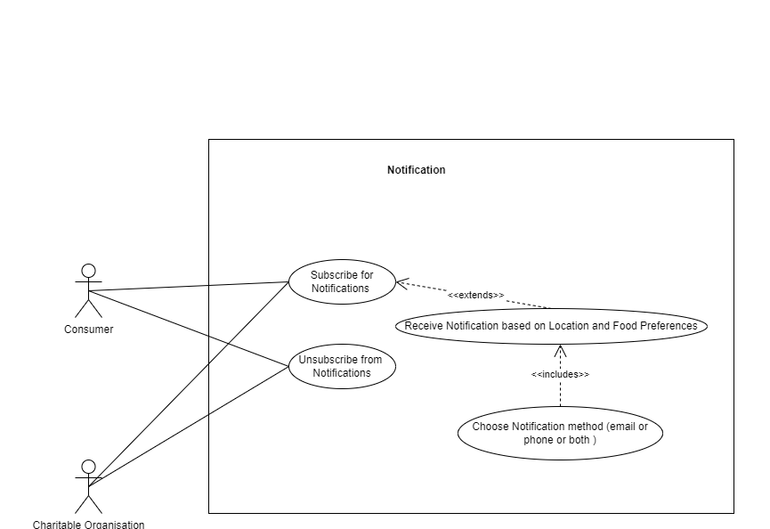

Figure 4: Notification Management Use Case

**Use Case Title:** Notification Management

**Use Case ID:** 03

**Actors:** Consumer, Charitable Organizations

**Description:** Consumers and charitable organizations receive notification they had signed up for regarding food surplus within their city according to their food preferences. They can choose whether to be notified using email, phone, or both.

**Preconditions:**

* Consumers and charitable organizations have registered and logged in to the system. (Use Case 01)
* Retailers within the city have updated their inventory surplus. (Use Case 02)

**Main Success Scenario:**

1. Consumers and charitable organizations can subscribe for notification.
2. Consumers and charitable organizations can choose whether to receive notification via email or phone.
3. Consumers and charitable organizations can set food item preference.
4. Consumers and charitable organizations receive notification for food surplus near them according to their food preference.
5. Consumers and charitable organizations can unsubscribe from notification.

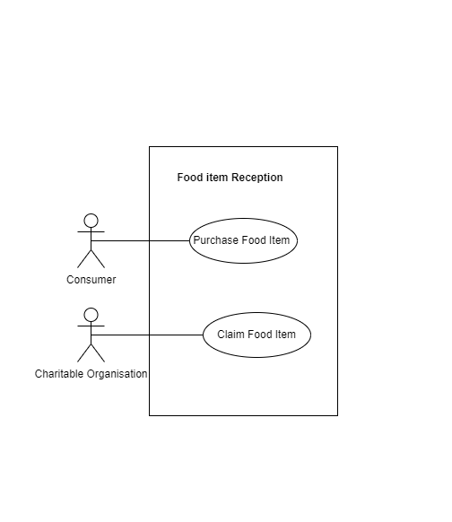

Figure 5: Food Item Reception Use Case

**Use Case Title:** Food Item Reception

**Use Case ID:** 04

**Actors:** Consumers, Charitable Organization

**Description:** Customers and charitable organizations can receive surplus food from retailers, either through purchase or through claim.

**Preconditions:**

* Consumers and charitable organizations have registered and logged in to the system. (Use Case 01)
* Retailers within the city have updated their inventory surplus. (Use Case 02)

**Main Success Scenario:**

1. Consumers can buy surplus food from retailers at a discounted price.
2. Charitable organizations can claim surplus food from retailers.

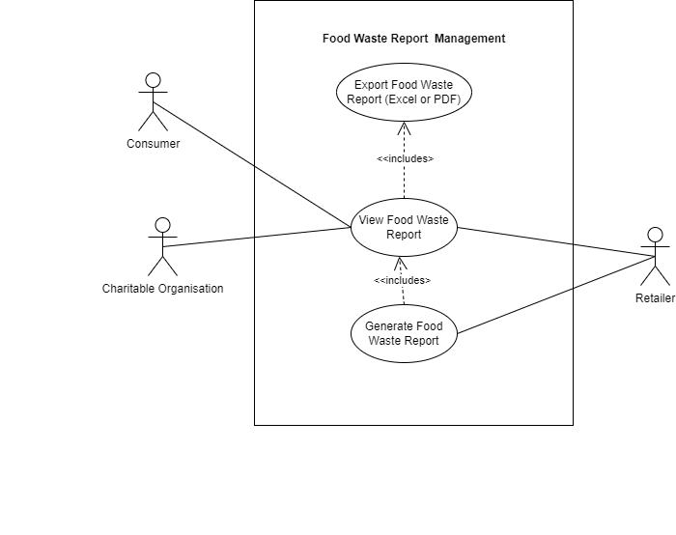

Figure 6: Food Waste Report Management Use Case

**Use Case Title:** Food Waste Report Management

**Use Case ID:** 05

**Actors:** Retailer, Consumer, Charitable Organization

**Description:** Retailers can manage excess inventory by obtaining access to and exporting food waste information reports from the system. These reports help discover opportunities for development by providing data onfood waste due to expiry or lack of consumption. To improve accountability and transparency, retailers can export reports in xlsx or pdf format to review and share food waste management details.

**Preconditions:**

* Retailers have registered and logged in to the system. (Use Case 01).
* Consumers and charitable organizations have registered and logged in to the system. (Use Case 01).

**Main Success Scenario:**

1. Retailers can generate custom reports for food waste management.
2. Consumers, charitable organizations, and retailers can view the food waste report and export the report.
3. The system can create thorough waste food report including quantity, kind, within the designated period.

# 7. Detailed Design

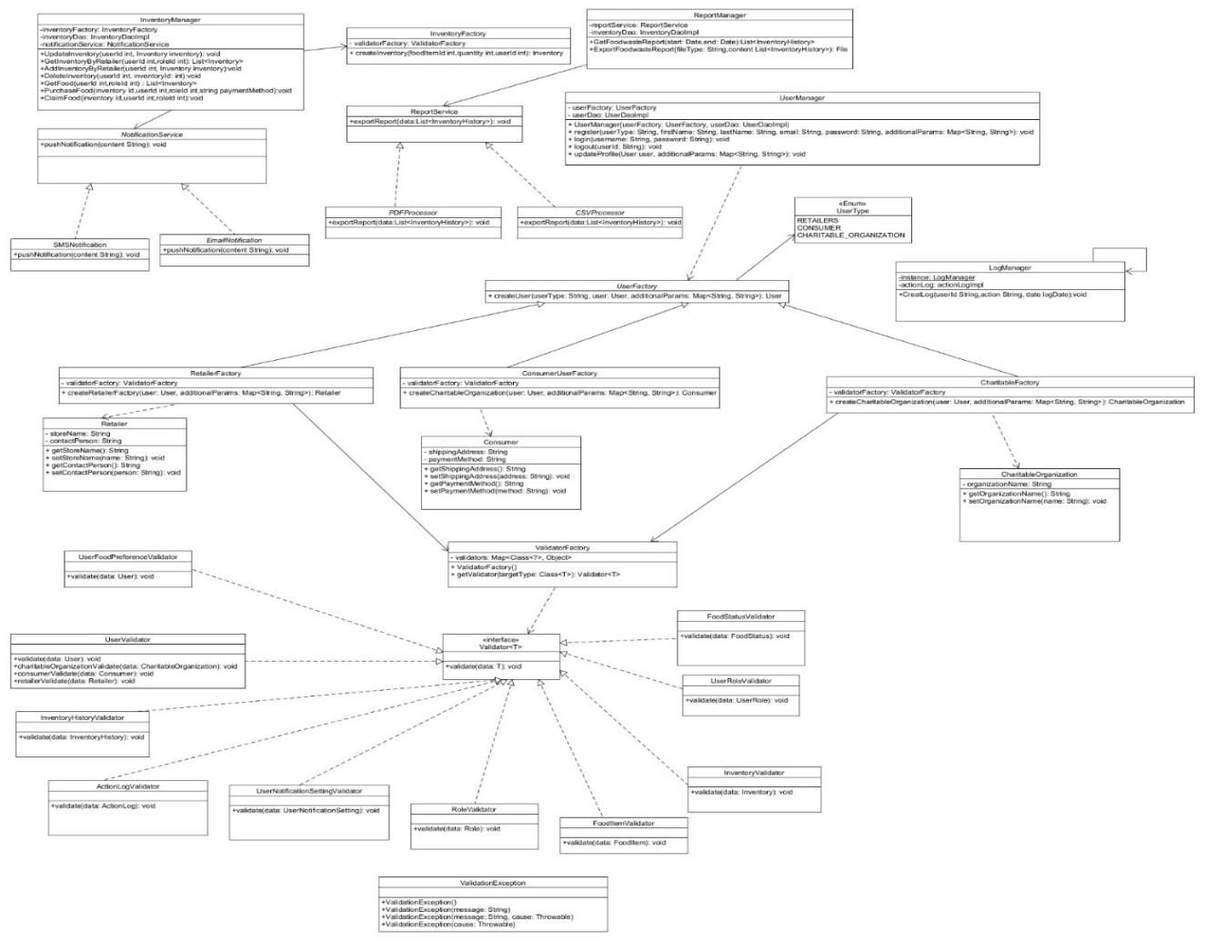

Figure 7: Class Diagram 1

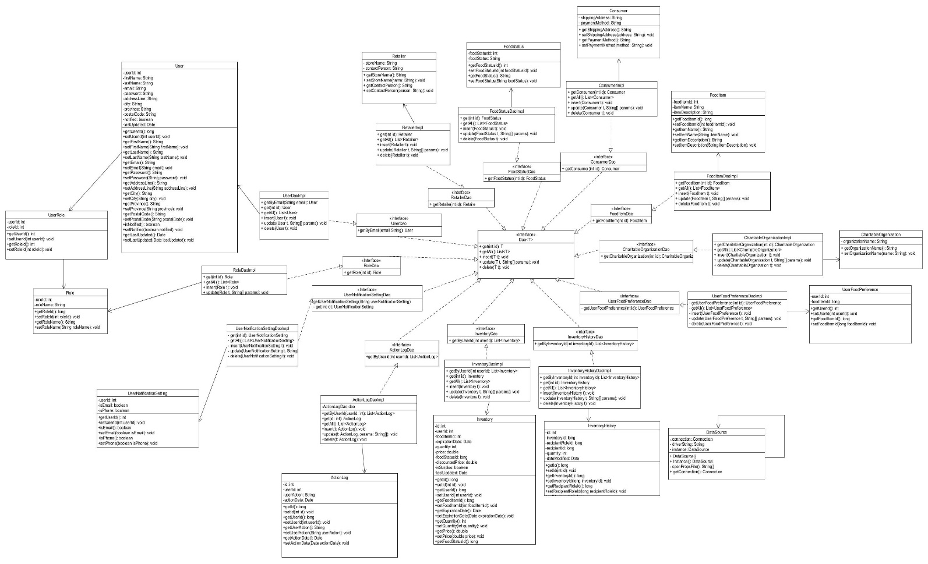

Figure 8: DAO Class Diagram

8. Data Architecture

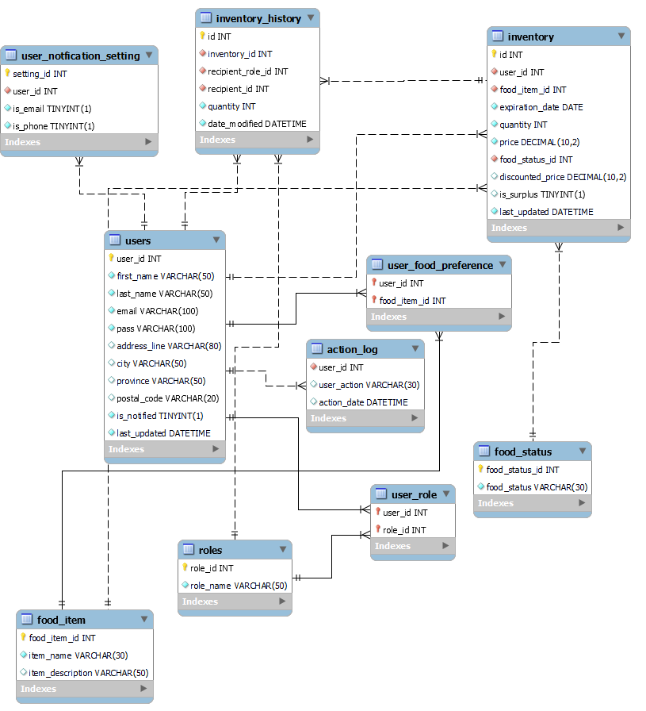

Figure 9: Data Architecture

## Table Structure and Relationships

**USERS TABLE:**

* user_food_preference: 1:M
* user_notification_setting: 1:M
* inventory: 1:M
* action_log: 1:M

**ROLES TABLE:**

* users: N:M through the user_role table

**FOOD_STATUS:**

* inventory: 1:M

**FOOD_ITEM:**

* user_food_preference: 1:M
* inventory: 1:M

**USER_ROLE:**

* users, roles: junction table, N:M

**USER_FOOD_PREFERENCE:**

* users, food_item: established M:N relationship between them.

**INVENTORY:**

* users: M:1
* food_item: 1:M
* food_status: 1:M

**USER_NOTIFICATION_SETTINGS:**

* users: 1:1

**INVENTORY_HISTORY:**

* inventory: 1:M
* roles: 1:M
* users: 1:M

**ACTION_LOG:**

* users: 1:M

# 9. Testing Model

The testing of the Food Waste Reduction Platform (FWRP) will be conducted using the JUnit testing framework, a popular tool for unit testing in Java applications. JUnit provides a simple and efficient way to write and execute test cases to validate the functionality of individual components and ensure their correctness.

Testing Model for Food Waste Reduction Platform (FWRP)

1. User Registration and Login

**Test Scenarios:**

* Verify user registration for consumers, retailers, and charitable organizations.
* Ensure the validation of all required fields (such as username, password, email, phone).
* Test that users can log in to their accounts with the right username and password.
* Test that users can log out of their accounts.
* Verify that users can manage their account (update location, change email, delete account).

2. Retailer Inventory Management

**Test Scenarios:**

* Verify that stores can add new food products to their inventory.
* Verification to see whether stores may update their existing food inventory.
* Test deleting food items from the inventory.
* Verify that the system appropriately marks food products that are about to expire in 7 days.
* Test to make sure that food discounts are applied accurately.
* Test the documentation of purchased or claimed food items in the inventory.
* Verify correct management of unbought and unclaimed food products, which will lead to soft deletion.

3. Notification Subscription

**Test Scenarios:**

* Ensure that customers and charitable organizations can subscribe for alerts.
* Test the notification's preference settings for notification delivery (email, phone, or both).
* Verify consumers may customize their food item selections for alerts.
* Ensure that alerts for food surplus are received in accordance with user settings.
* Test out the unsubscribe functionality for alerts.

4. Food Waste Information Reports

**Test Scenarios:**

* Verify that shops may create reports for food waste control.
* Ensure that food waste reports are accessible to consumers, charity groups, and merchants.
* Test the export feature for reports in Excel or PDF format.
* Test that the system provides detailed food waste data, including amount, kind, and timeframe.

5. Cross-Functional Testing:

**Integration Testing:**

* Test interaction between client registration/login and other use cases to ensure smooth flow.
* Verify integration between retailer inventory data and subscription data to notify clients at the right time.
* Test integration between retailer inventory data and food waste data to maintain data accuracy and synchronization.

**Security Testing:**

* Ensure that authentication and authorization is applied to every user and role.
* Test whether user input in registration and login is risky.
* Verify that passwords and personal information are securely stored in keeping with data privacy.

**Usability testing:**

* Test whether a user can intuitively navigate through user interface.
* Collect feedback regarding registration, login, and inventory management interface.
* Ensure that the user can easily set notification subscription and preference.

# 10. References

[1] “Food and Organic Waste Framework,” Ontario.ca, 2019. Available: <https://www.ontario.ca/page/food-and-organic-waste-framework> [Accessed:15 March 2024].

[2] Ontario.ca, 2020. <https://www.ontario.ca/page/food-and-organic-waste-policy-statement> [Accessed: 15 March 2024].

[3] A. and A.-F. Canada, “Government of Canada launches Food Waste Reduction Challenge,” gcnws, Nov. 19, 2020. <https://www.canada.ca/en/agriculture-agri-food/news/2020/11/government-of-canada-launches-food-waste-reduction-challenge.html> [Accessed: 15 March 2024].

# 11. Acronyms/Abbreviations

FWRP: Food Waste Reduction Platform

# 12. List of Figures

Figure 1: Application Architecture 5

Figure 2: User Registration and Login Use Case 8

Figure 3: Retailer Inventory Management Use Case 9

Figure 4: Notification Management Use Case 11

Figure 5: Food Item Reception Use Case 12

Figure 6: Food Waste Report Management Use Case 13

Figure 7: Class Diagram 1 14

Figure 8: DAO Class Diagram 15

Figure 9: Data Architecture 16